Report on the export and publishing of Meta Spark Ar Effects

I am the only person with facebook functional enough to work with it, however, i cannot call myself or participate in group video calls alone, as such testing the effect on myself.

The ipads used do not have meta player as such i will be testing them on my phone instead, barring UI size changes as well as performance issues

The hand UI seems to be on a render layer closer to the camera. However, it leaves a trail of invisible squares, likely the image's alpha channel the same size as itself. the newly created trail replaces the rest of the UI as well as any underlying objects.

Normal FPS: 30

Suspected memory leak issue, as above. 5 mins of testing yielded a result of 14fps, less than half of the frames.

Lack of UI design as the UI elements are blocked by the effect select wheel as well as the various capture modes at the bottom of the screen.

Testing on android mobile for this testing session.

## Apple Frenzy

Hand cuts away the UI and any other underlying images.

Messenger video call doesn't export.

Noted cause; SharpWrap Property

Effect: upload failed, cannot test on call

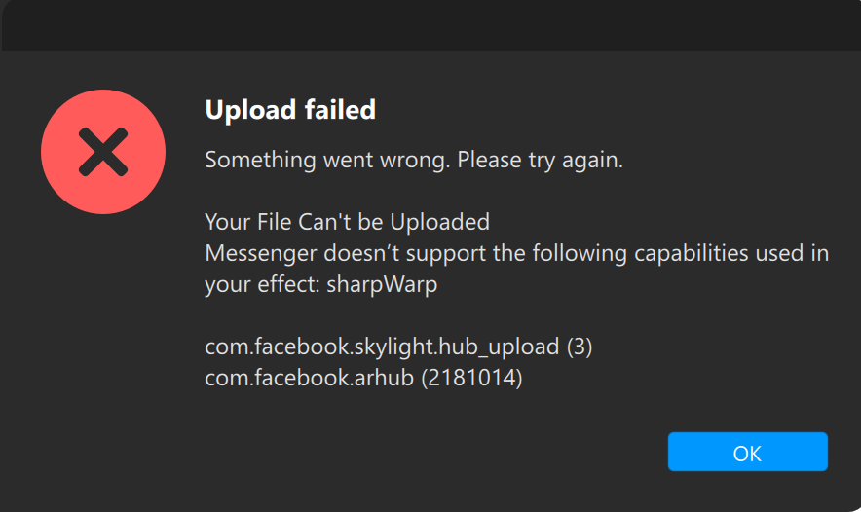

## Beach Bomb

UI scaling issue where the last star is stretched

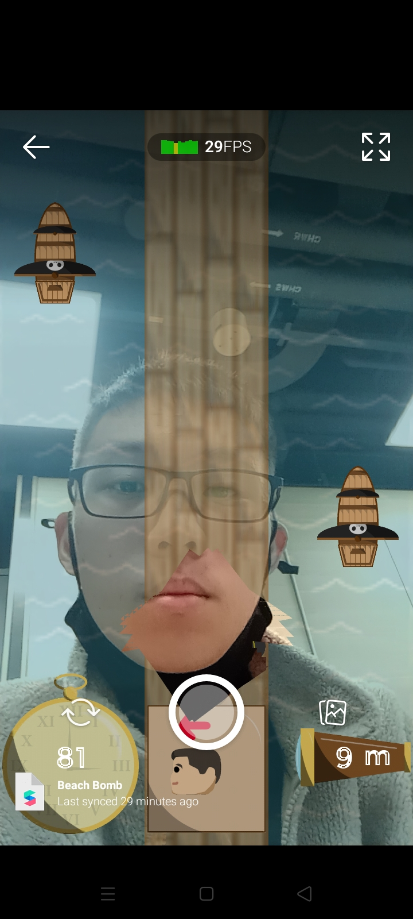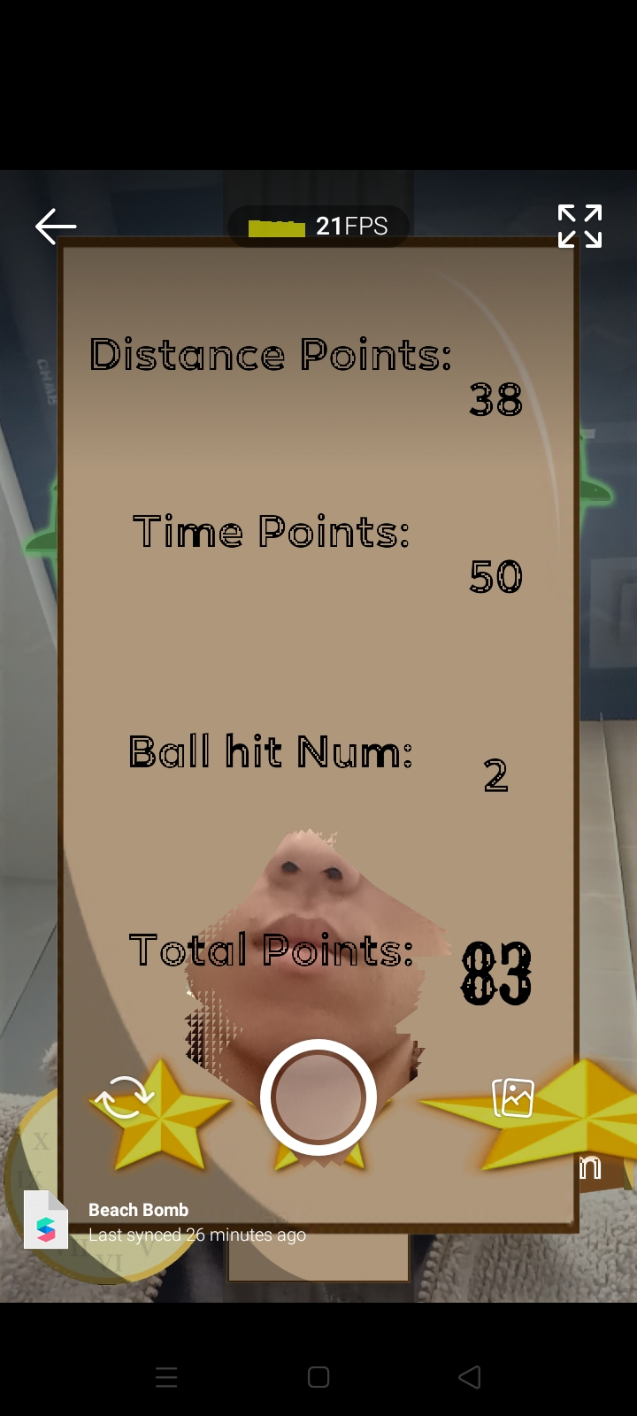

Follows the issues above, in Apple Frenzy, where it does not export via the messenger. Due to long load times(over 10 mins), as such unable to test it. Multiple tries later, the same issue arises without noticeable cause.

## SingaBall

Follows the issues above, in Apple Frenzy, where it does not export via the messenger. Due to long load times(over 10 mins), as such unable to test it. Multiple tries later, the same issue arises without noticeable cause.

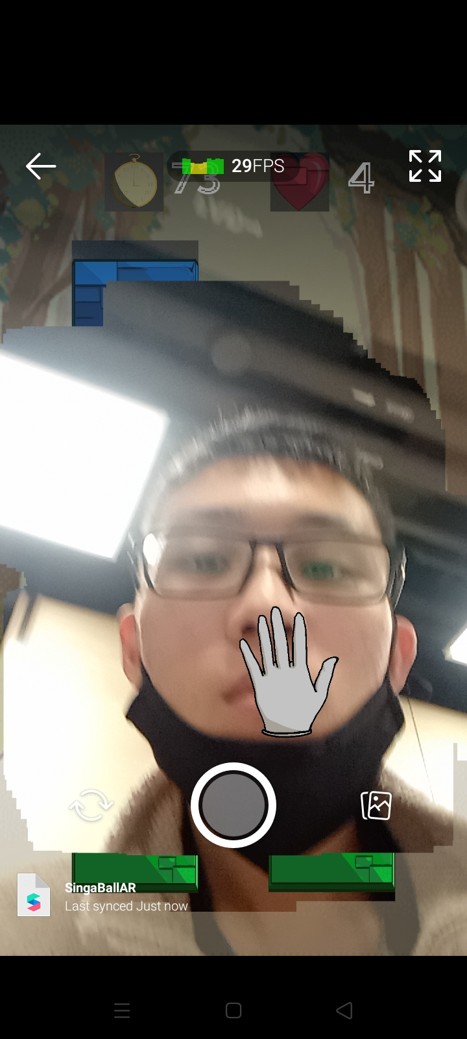

## Step Up Right

Successfully exported via messenger effects No further testing

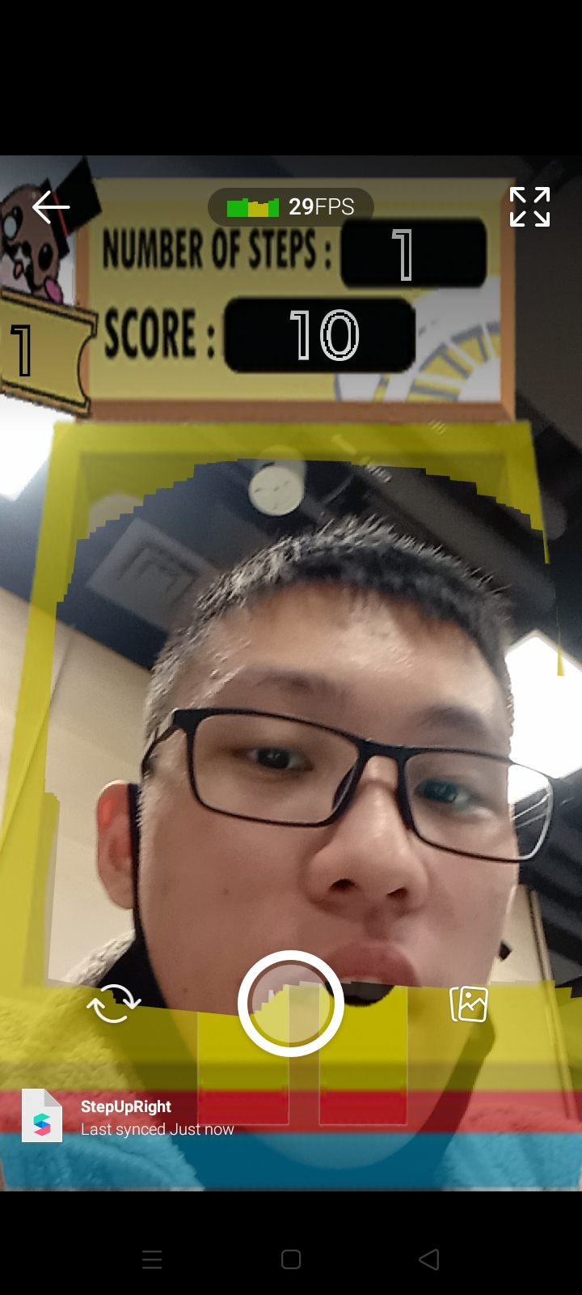

# Revised report - 20/12/2023

New test on the SM-X700, successfully downloaded the application(Mobile Meta Spark Player) needed and a new testing session is underway.

Awaiting login on the Messenger app on the SM-X700 to continue testing for the video calling segment.

Overall testing results: UI doesn't get covered by the hand UI bug, where the hand/face tracker is generating invisible patches that replaces/covers the UI over time. This has also improved performance as there are no memory leaks or additional render calls.

## SM-X700 Mobile Meta Spark Player

Testing using USB cable connection, connection is stable and the effect was visible and easily tested.

### Apple Frenzy

All gameplay elements inside, mechanics and collisions work as intended. Stable 30 fps over time. Replayable effects and rather fast/accurate face tracking,

### Beach Bomb

All gameplay elements inside, mechanics and collisions work as intended. Stable 30 fps over time. Slight reduced accuracy on face detection as the character does not move as fast as expected, using both the simulated facecam video on the laptop as well the tablet.

### SingaBall

2 tests taken to transfer the effect to the tablet, both failed as the load times were too long.

Testing on mobile, showed a negative countdown timer that counts up instead, then continuing to track the game progress. Tentative fix is to Absolute the text on the UI to show a countdown effect, while overlaying a splash text on the beat.

### Step Up Right

All gameplay elements inside, mechanics work as intended. Stable 30 fps over time. Face tracking hammer is a 3d object that is attached to the face, the rotation of the object was a little clunky but otherwise responsive. The collision detection was slightly off, on account of the radial detection used. Replacing the radial detection with AABB boundary may solve the issue of the hammer not being detected, with slightly higher computation cost.

## Messenger Video Call

### Apple Frenzy

Messenger video call doesn't export.

Noted cause; SharpWrap Property

Effect: upload failed, cannot test on call



### Beach Bomb

Successful video call, with slight UI errors as well as scaling due to the different size of the Ipad VS tablet. Vice versa on separate devices, where the UI on the Ipad is too small for the tablet, and the UI on the tablet is too large for the Ipad.

Noted slightly longer load times but successful after 2nd try.

### SingaBall

Unable to test due to long load times that broke connection between laptop and tablet. Multiple tests underway, failed via long load times.

### Step Up Right

Successful video call, with slight UI errors as well as scaling due to the different size of the Ipad VS tablet. Vice versa on separate devices, where the UI on the Ipad is too small for the tablet, and the UI on the tablet is too large for the Ipad.

Slightly harder to play due to inaccurate face tracking on the video call, with unequal offsets from the edges.